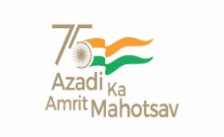
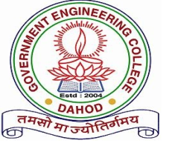
GOVERNMENT ENGINEERING COLLEGE
DAHOD
SSIP CELL
REPORT ON “STUDENT STARTUP RESEARCH & INNOVATION FESTIVAL”
As part of celebration of Student Startup Reserch & Innovation Festival under Azadi ka Amrut Mahotsav, an event named ‘Startup Journey & Sensitization of SSIP 2.0’ has been organized at Government Engineering College (GEC) Dahod on 4th October, 2022. The event was organized at Seminar hall, admin building of GEC Dahod. Mr. Shaileshbhai Ninama, Sarpanch – Chhapri gam, has been invited as chief guest. 105 students from Government Engineering College and Government Polytechnic Dahod have participated in the event. The event was started by lamp lighting by chief guest Mr. Shailesh Ninama, Principal Dr. P. B. Tailor and other dignitaries present followed by a prayer. After welcoming the chief guest, Principal has announced the starting of the function and elaborated various achievements and benefits derived from the first phase of Student Startup & Innovation Policy by GED Dahod. Then the institute SSIP 2.0 coordinator Dr. M. K. Chudasama has briefly discussed Vision, Mission and various provisions of SSIP 2.0 with the help of AV presentation. He has also emphasized on actively participation of the students in various national and state level events organized by i-hub and various institutions to know about the startup ecosystem in the state of Gujarat. In the next phase of the event, an online presentation of one of the alumni-student Mr Gaurav Chale, who is cofounder of startup ‘Bogiesauf’ was arranged. He has explained his startup journey, how his team has identified the problem and arrived at solution with the help of institute mentors. He has also explained how various SSIP (first phase) interventions have helped he and his team file the patent, develop the prototype and start the startup. It was very interactive session and the participants have actively participated in it. The participants were excited to see that how a student hailing from their own institute has achieved various milestones with the help of financial, infrastructural and mentoring provided by the institute faculties through SSIP activities.
In the next session, various students were facilitated by awarding the sanction letters by chief guest Mr. Shailesh Ninama. In the end the departmental SSIP coordinator Dr. C. D. Upadhyay has presented vote of thanks. He thanked the invited chief guest Mr. Shileshbhai Ninama, Faculties and students from GEC Dahod and Government Polytechnic Dahod. The event was concluded by recitation of the national anthem.
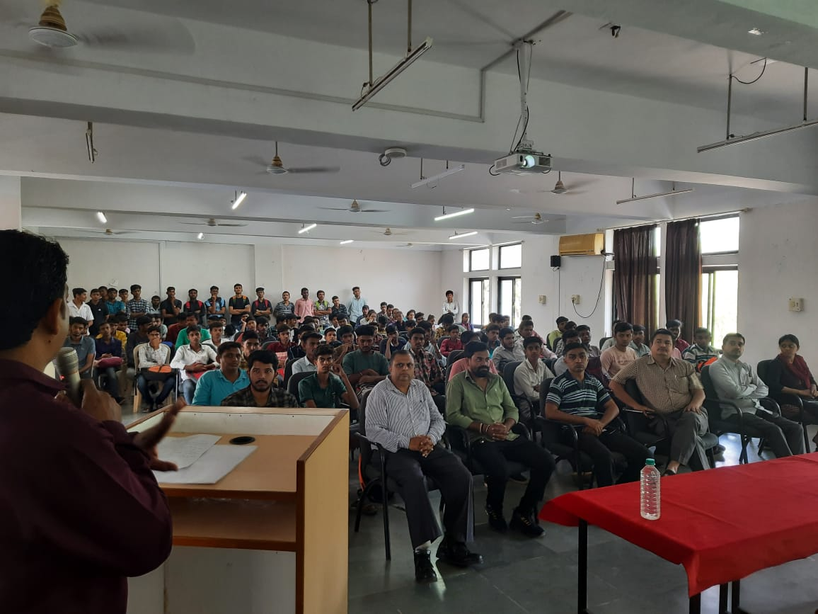

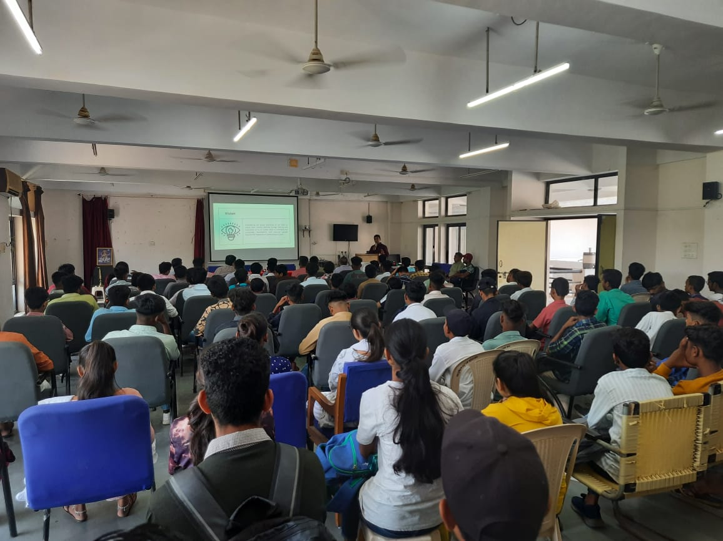
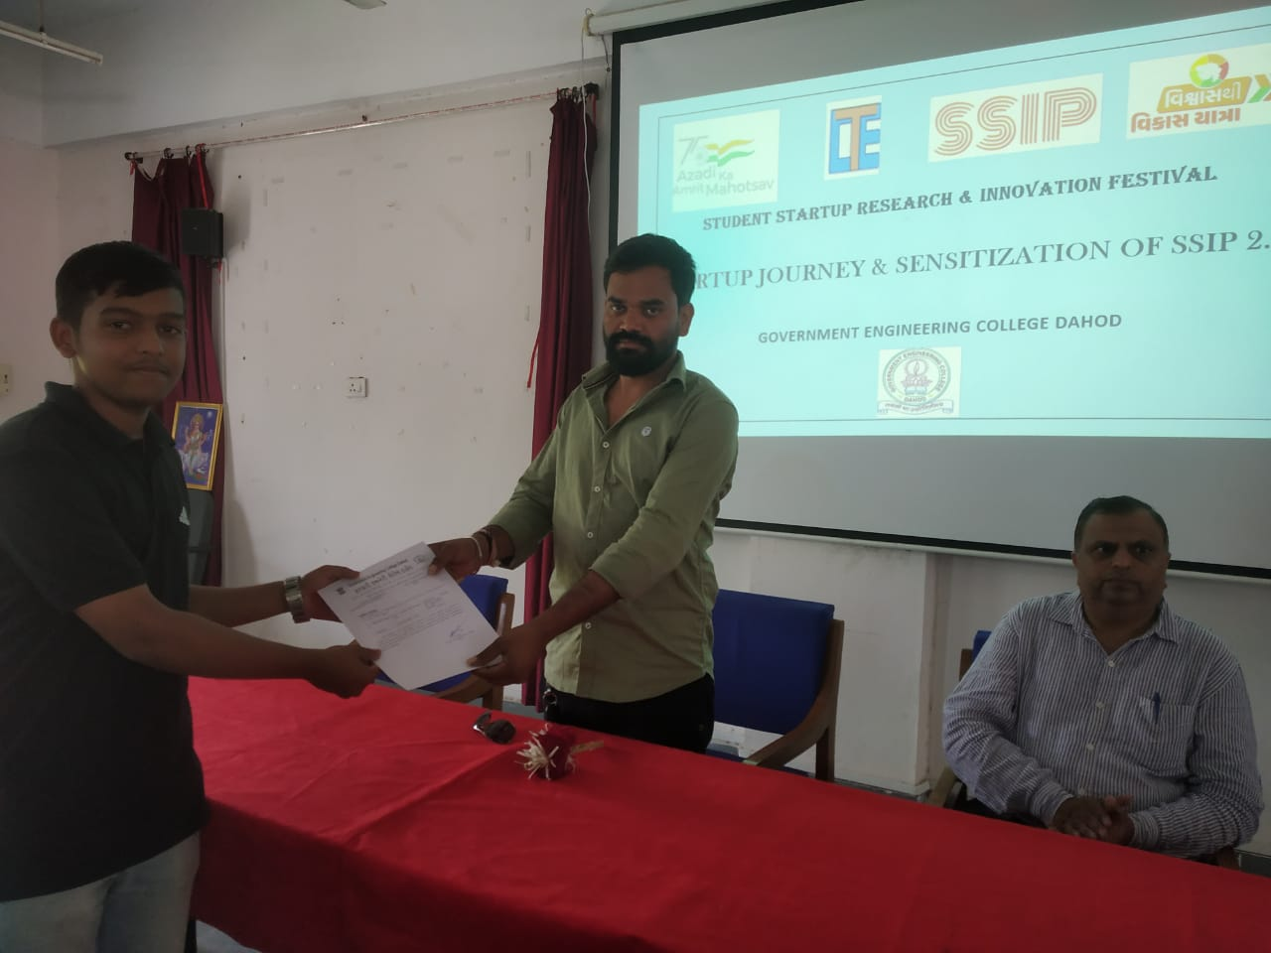
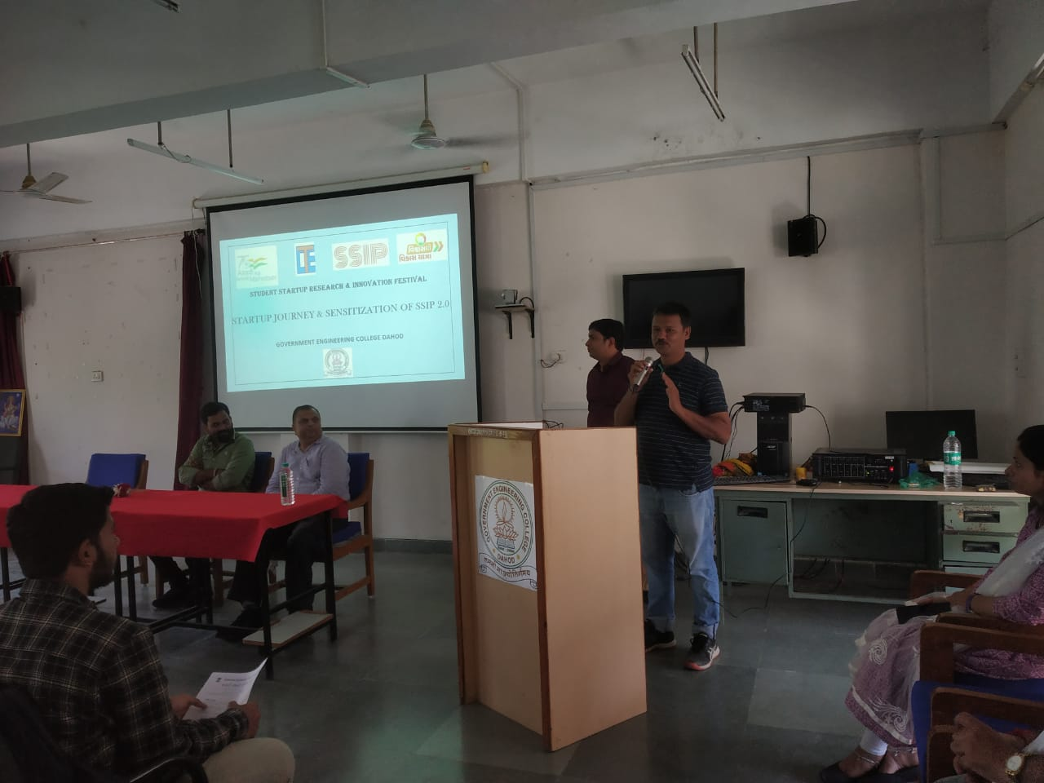
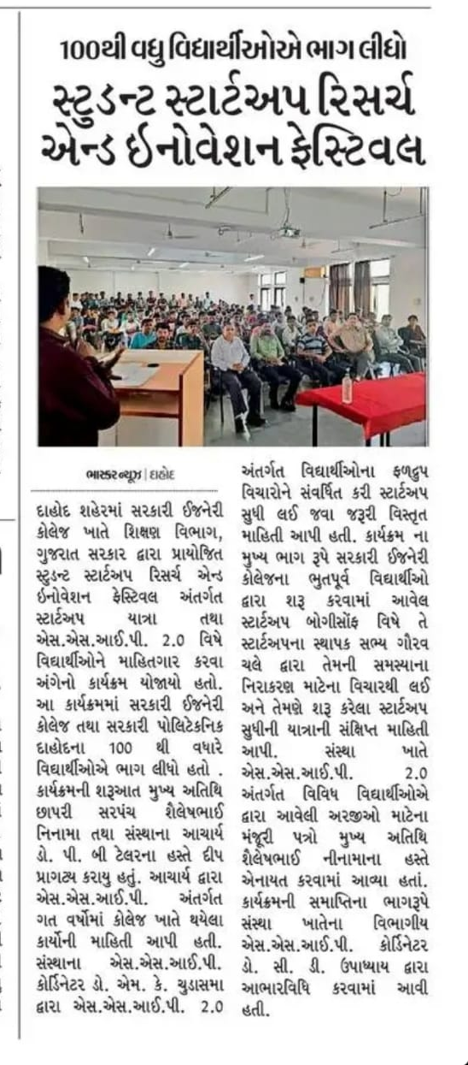
Media coverage of the event

